**Arab Academy for Science and Technology**

Faculty of Engineering



**Linker-Loader Report**

**(December 2022)**

Submitted by: Philimon Elkess Dawoud

Department: Computer Engineering

Registration Number: 19102648

Submitted to: Dr. Noha Seddik

Submitted on: 12/12/2022

Table of contents Page number

1.0 About Project............................ ……………......……………………………………………..1

2.0 Sample Input SIC/XE........................................ ………………….........……………..............2

3.0 Sample Input SIC............................................... ………………….........……………..............2

3.0 Ext_Sym_Table.txt …....………………………..........…….....................................…...…….3

4.0 Loading SIC.. ………………………...………………….……………...........................….…4

5.0 Loading SIC/XE.. ………………………...………………….……...................………..….…5

6.0 Program Interacting ..................................................................................................................6

1. About Project

The project was generated by only one student using Python programming language for its flexibility and wide variety of functions, what makes it the best choice to work on such project.

The Linker-Loader project supports all kind of records. It helps the user by simulating what happens in a sic machine memory while loading and linking by showing a detailed GUI that represents SIC machine memory.

Options:

1. Program Alerts user if he entered invalid address
2. User input any file he want to load.
3. User input any starting address he wants.
4. User can choose to load SIC or SIC/XE program
5. The loading-linking operation is presented in a well-organized GUI that represents SIC machine memory

Sample Input SIC/XE

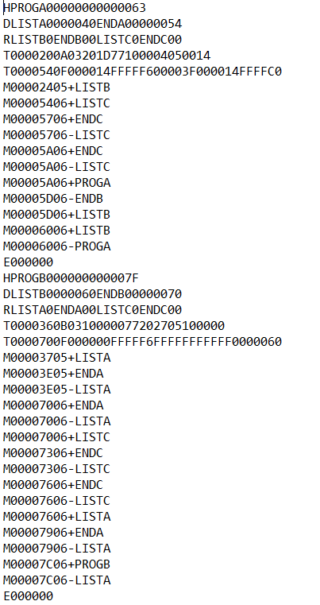

Sample Input SIC

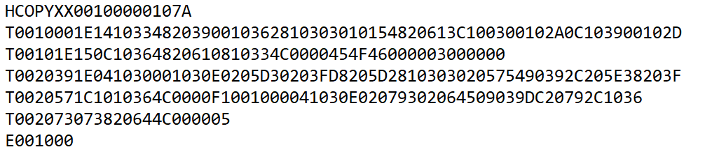

Ext_Sym_Table.txt

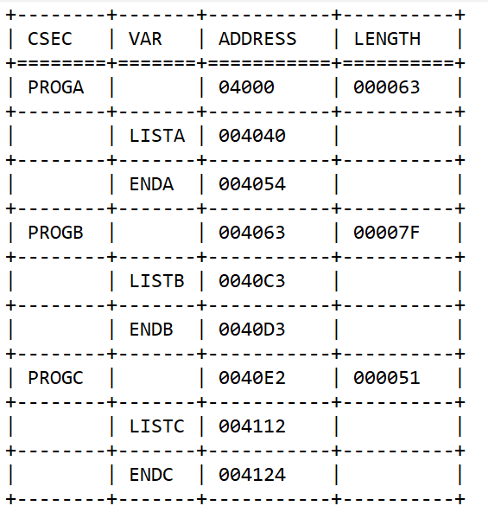

Loading SIC

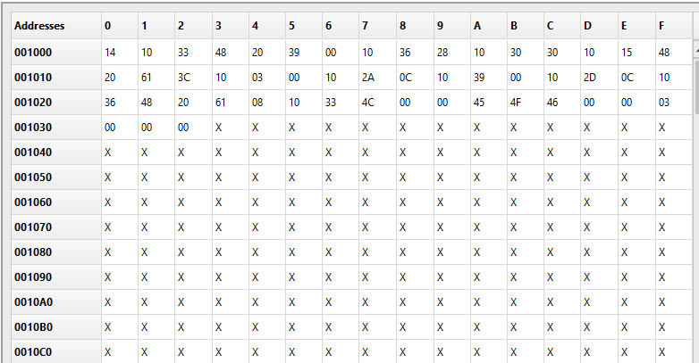

Loading SIC/XE

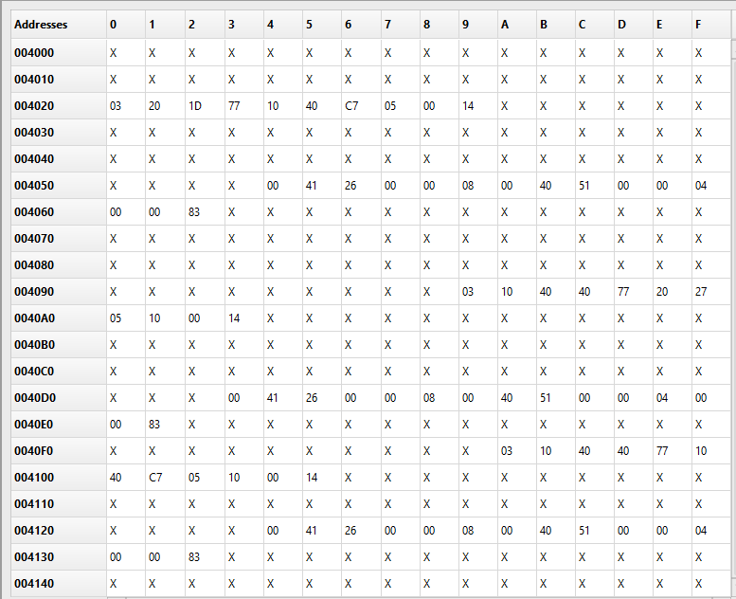

Program Interaction

